Thread 975952c5
Source: https://meta.remarkbox.com/975952c5-2b75-11f1-ab73-040140774501
Snapshot: 2026-04-30T12:56:12Z
Generator: Remarkbox 763cacb
This is a subthread snapshot. The living document lives at the source URI above — it may have been edited, extended, or replied-to since.
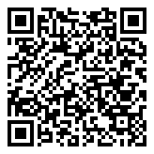
Scan for living source
<3

Source: https://meta.remarkbox.com/975952c5-2b75-11f1-ab73-040140774501
Snapshot: 2026-04-30T12:56:12Z
Generator: Remarkbox 763cacb

